A
P
P
E
N
D
I
X
Appendix I Syllabus
SILABUS
Satuan Pendidikan | : SMP
Mata Pelajaran | : Bahasa Inggris
Kelas/Semester | : VIII / 2 (Genap)
Alokasi Waktu | : 4 x 40 (4x pertemuan)
Tahun Pelajaran | : 2023/2024
Standar Kompetensi (KI)
KI-5 | : Membaca Memahami makna teks tulis fungsional dan esei pendek sederhana berbentuk descriptive dan recount yang berkaitan dengan lingkungan sekitar.

Kompetensi Dasar | Materi Pembelajaran | Indikator | Nilai Karakter | Kegiatan Pembelajaran | Alokasi Waktu | Sumber Belajar | Penilaian
5.3 Merespon  makna dan  langkah retorika dalam esei pendek sederhana secara akurat, lancar dan berterima yang  berkaitan dengan lingkungan sekitar dalam teks berbentuk  descriptive dan recount | - Fungsi sosial melaporkan, mengambil teladan, membanggakan  - Struktur teks dapat mencakup  - Orientasi  - Urutan kejadian/kegiatan  - Orientasi ulang  - Unsur kebahasaan  - Kalimat deklaratif dan interogatif dalam Simple past tense  - Adverbia dan frasa preposisional penujuk waktu: yesterday, last, month, an hour ago, dan sebagainya  - Adverbia penghubung waktu: first, then, after that, before, at last, finally, dan sebagainya  - Nomina singular dan plural dengan atau tanpa a, the, this, those, my, their, dbs.  - Ucapan, tekanan kata, intonasi, ejaan, tanda baca, dan tulisan tangan  - Topik  Peristiwa, pengalaman yang terjadi disekitar lingkungan dan yang dapat menumbuhkan perilaku yang termuat di KI. | - Membaca dengan cermat dan bermakna teks tulis fungsional pendek berbentuk recount.  - Mengidentifikasi gagasan dalam teks:  - Main idea  - Supporting ideas  - Mengidentifikasi generic structure:  - Orientation  - Complication  - Resolution  - Memahami makna dalam teks.  - Makna tersirat/tersurat  - Mengidentifikasi berbagai informasi dalam teks  - Membuat kesimpulan  - Memahami kosakata | - Religius  - Mandiri  - Tanggung Jawab  - Kejujuran  - Kreatif  - Percaya diri  - Kerja sama | - Survey: siswa melihat dengan cepat keseluruhan materi sebelum membaca secara rinci  - Question: merumuskan pertenyaan-pertanyaan yang dapat membimbing fokus saat membaca  - Read: membaca dengan aktif untuk mencari jawaban atas pertanyaan yang telah dirumuskan  - Recite: mengulang materi dengan mengingat kembali informasi yang telah dibaca  - Review: meninjau kembali materi untuk memastikan pemahaman dan mendapat informasi dengan baik |  | - Buku Penunjang Kurikulum 2013 Mata Pelajaran Bahasa Inggris BRIGHT An English Course for Junior High School Students  For SMP/MTs Grade VIII. NUR ZAIDA  - Kamus Bahasa Inggris  - Pengalaman peserta didik dan guru | - Lisan  - Tertulis  - Penugasan  - Unjuk kerja  - Portofolio

Appendix II Lesson Plan Cycle 1

RENCANA PELAKSANAAN PEMBELAJARAN (RPP)
CYCLE 1

Nama Sekolah : SMP Muhammadiyah 2 Pontianak
Mata pelajaran : Bahasa Inggris
Kelas/Semester : VIII
Alokasi Waktu : 2 x 40 menit (2x pertemuan)
Topik Pembelajaran : Recount Text
Pertemuan Ke : 1-2

- Standar Kompetensi (KI)
Membaca
- Memahami makna teks tulis fungsional dan esai pendek sederhana berbentuk recount teks yang berkaitan dengan lingkungan sekitar.

- Kompetensi Dasar
  - Membaca nyaring bermakna teks tulis fungsional dan esai pendek sederhana berbentuk recount teks pendek dan sederhana dengan ucapan, tekanan, dan intonasi yang berkaitan dengan lingkungan sekitar.

- Indikator Pencapaian Kompetensi
Siswa dapat:
- Membaca dengan cermat dan bermakna teks fungsional pendek berbentuk recount.
- Mengidentifikasi gagasan dalam teks.
- Main idea
- Supporting ideas
- Mengidentifikasi generic structure
- Orientation
- Complication
- Resolution
- Memahami makna dalam teks.
- Makna tersirat/tersurat
- Mengidentifikasi berbagai informasi dalam teks fungsional pendek berbentuk recount.

- Tujuan Pembelajaran
Pada akhirnya pembelajaran siswa dapat:
- Membaca dengan baik teks recount
- Mengenali berbagai informasi pada teks recount

- Materi Pembelajaran
Tema traveling
CROSSING THE STRAIT OF BALI
Orientation Last holiday, I had trip to Bali. I went there with my schoolmates. We travelled by bus. It was the school program for the student to have the study tour. We left school on June 17 It was Saturday. We left school at about 2 p.m.
Event After leaving school, the buses rolled fast toward the island of Bali We passed many cities in Central and East Java. It was very interesting. We enjoyed the view a long the road. About in 5 in the morning the next day, we arrived at Ketapang in Banyuwangi. We came to the port and continued going on board of the ferry. We began to enjoy the view of the sea, the strait of Bali.
A few moments before we landed in Gilimanuk a port of Bali, we got surprised. There were many boys climb up the ferry.
Orientation Last weekend was my luckiest day ever. Many good things were coming toward me. When the morning broke in Sunday morning, I woke up and planned to jog around the neighborhood.
Events So I changed my clothes and went to the bathroom to wash my sleepy face. As I stepped in the bathroom, I landed my foot on a soap in the floor and feel down. A perfect morning hi for me. Next, I began my jogging and saw my gorgeous neighbor, jogging to. I though it was a good fortune to omit the gap between us. So, I jogged to him and say hello. But, how poor of me, it was not him. It just someone I never met before who looked like to him. I was going home with people laugh at me along side of the street. When I got home, the breakfast already settled and I immediately spooned a big portion of rice and ate. After I have done my breakfast, my mother came up and said that the meal has not ready yet and she said that I may have a stomachache if I ate it It was proven, I had a stomachache for the next three days.
Re-orientation I passed my weekend lie down on me bed and be served as a queen. That was not bad, was not it.
Last week, my friend and I rode our bikes to the beach. It was only five kilometers from our houses.
It was quite windy and there was hardly anyone there. It surprised us because there were always many people coming there on the weekends. So, we had the beach on our own. We bought some hot chips, rode our bikes, played in the water, and sat under the trees. We really had a great time.
- Where did the story happen?
- in a house c. at the store
- in a water d. at the beach
- How did they go to the beach?
- by bicycles c. by bus
- by car d. by boat
- Who did the writer and his friend find when they reached the beach?
- many people c. almost no more
- many visitors d. foreign tourist
- How didi the writer thinks about the trip?
- It was an unpleasant trip c. It was a funny trip
- It was a horrible trip d. It was a good trip
- “It was only five kilometers from our house.” (line 1) The word “it” refers to ….
- bike c. beach
- chip d. house

- Model Pembelajaran/Teknik
SQ3R

- Sumber/Bahan/Alat
Buku teks yang relevan: BRIGHT An English Course for Junior High School Students For SMP/MTs Grade VIII. NUR ZAIDA

- Langkah-langkah Kegiatan Pembelajaran
Kegiatan Awal (10 menit)
Eksplorasi
- Doa sebelum belajar
- Greeting in English
- Mengecek kehadıran siswa dan mempersiapkan siswa mengikuti pelajaran
- Menyampaikan materi yang akan dipelajari dan indikator yang ingin dicapai
- Memotivasi siswa untuk mengikuti pelajaran dengan baik
Kegiatan Inti (40 menit)
Elaborasi
- Siswa membaca teks recount selama 15 menit
- Siswa mempelajari tujuan komunikatif dan langkah retorika teks recount yang dijelaskan oleh guru
- Siswa mempelajari kalimat yang mewakili orientation, complication dan resolution
- Siswa mempelajari kata-kata yang kunci dalam teks untuk menentukan gambaran umum, informasi rinci dan informasi tersurat
- Siswa mencari kata-kata yang sulit dalam teks
- Siswa menemukan arti kata yang sulit
- Siswa didalam kelompok dengan bumbingan guru mengidentifikasi teks berbentuk recount dengan menggunakan SQ3R
- Siswa mencari kata-kata yang kunci dalam teks untuk menentukan gambaran umum, informasi rinci dan informasi tersurat
- Siswa menjawab pertanyaan bacaan
- Siswa mengidentifikasi jenis, fungsi, dan generic structure text, dan language feature yang dipakai teks tersebut berdasarkan tugas dari masing-masing anggota:
- Predicting siswa memprediksi tentang teks dari title of the text dan memprediksi apa yang ingin disampaikan penulis dalam setiap paragrap didalam teks.
- Questioning siswa dalam masing-masing regunya bertanya jawab tentang topik dan informasi yang kurang jelas dalam teks.
- Clarifying siswa akan berbicara tentang bagian teks yang kurang jelas dan menjawab pertanyaan-pertanyaan yang menjadi permasalahan pembaca.
- Summarizing siswa memberikan poin terakhir dan menggaris bawahi mengenai gagasan penting atau kunci, berdasarkan pemahaman terhadap teks.
Kegiatan Penutup (10 menit)
Konfirmasi
- Siswa memperhatikan simpulan tentang hal2 yang diajarkan guru Siswa memberi refleksi/komentar tentang hal-hal dan telah dipahami maupun hal? yang dipelajari baik yg menyenangkan atau tidak menyenangkan
- Guru memberikan tugas tindak lanjut berkaitan dengan materi pilihan ganda (multiple choice) berbentuk recount text
- Salam penutup (Closing)

- Penilaian
- Indikator, Bentuk dan Contoh
No | Indikator | Teknik | Bentuk | Contoh
1. | - Mengidentifikasi gagasan utama (main idea) & supporting detail dalam teks recount  - Generic structure | Tes tulis | Pilihan ganda | - What is the main idea of the paragraph 2?

- Instrumen Penilaian

Direction: read the following text carefully and then choose the correct answer by choosing a, b, c, d, or e!

Text 1 for questions number 1 to 3.

That morning, I got dressed as usual I was just leaving for school when 1 noticed that my shoes were filthy, I went back inside to polish them Staying home those five extra minutes probably saved my life.
When I came outside again, my mother was on the lawn picking flowers. Somebody yelled, "Tsunami!" We thought it was an April Fool's joke. Then, I looked up and saw a huge wall of dirty water My mother pushed me inside and slammed the door, just as the wave struck our house. It felt like we had been hit by a train.
The wave picked up the house, and we floated away Seawater came up to my knees. I decided to changed clothes, in case we had to swim When I opened the closet, the back wall was gone! All I could see past my hanging clothes were waves and dead fish. It looked liked a strange painting.
Through the windows we could see people floating by, holding onto whatever they could. A boy was clinging to a piece of lumber. The waves carried us far out into Hilo Bay and back again three times.
Our family was fortunate. And I am not nervous about tsunamis anymore. But when I got married, I told my husband, "We're not leaving at the beach. We are going to live in the mountains!"

- When did the Tsunami happen?
- In March c. One morning e. Some years ago
- In April d. Long time ago

- Where did the writer finally shelter from the tsunamis?
- In a factory wall c. In a factory e. In her house
- At the beach d. In the mountain

- "Our family was fortunate" (Paragraph 5)
The underlined word can be replaced by ….
- lucky c. properous e. lack of
- famous d. miserable
Text 2 for questions number 4 to 6.
Late in the afternoon, the boys put up their tent in the middle of a field. As soon as this was done, they cooked a meal over an open fire. They were all hungry and the food smelt good. After a wonderful meal, they told stories and sang songs by the camp fire. But sometime later it began to rain. The boys felt tired so they put out the fire and crept into their tent. Their sleeping-bags were warm and comfortable, so they all slept soundly. In the middle of the night, two boys woke up and began shouting. The tent was full of water! They all leapt out of their sleeping-bags and hurried outside. It was raining heavily and they found that a stream had formed in the field. The stream wound its way across the field and then flowed right under their tent.
- The purpose of the text is ….
- To retell about camping in the field
- To explain why the night was wet
- To persuade readers to believe event
- To tell what happened to the boys
- To present a point of view about camping

- Where did the stream flow? It flowed ….
- in the midle of the field d. near the boy’s tent
- across the field e. under the boy’s tent
- in front of the boy’s tent

- They told stories and songs after ....
- They had a meal
- The stream was across the field
- They slept soundly
- The tent was full of water
- It began to rain
Text 3 for question number 7 to 10.
Albert Einstein was born in 1879 in Germany. He graduated from the University of Zurich in Switzerland in 1905. In 1905 he also did some of his famous work in Physics. In 1919 he won the Noble Prize for Physics. Between 1919 and 1933 he lived in Germany and traveled a lot to talk to other scientists. Then, in 1933 he had to leave Germany because of Hitler and the Nazy Party. He moved to United States from 1933 until his death. He lived in Princetown, New Jersey. He died on 18th April 1955.
- What is the topic of the text?
- The achievement of Albert Einstein
- The life of Albert Einstein
- Albert Einstein’s chilhood
- Albert Einstein’s home town
- Albert Einstein’s study

- When did Albert Einstein win the Noble Prize?
- In 1905 c. In 1933 e. In 1955
- In 1919 d. Between 1919 and 1933

- Which of the following statements is True according to the text?
- Albert Einstein was a Deutsch
- Albert Einstein won the Nobel Prizes for Chemistry
- Albert Einstein had done some famous work in Physics before 1905
- Albert Einstein had spent the rest of his life in America for 21 years
- Albert Einstein died on age of 75 years old

- "In 1905 he also did some of his famous work in physics."
What is the similar meaning of the underlined word?
- Familiar c. Well known e. Very good
- Excellent d. Great
Text 4 for question 11 to 13.
Last week my friend and i were bored after two weeks of holidays, so we rode our bicycles to a beach, which is only five kilometres from where we live.
When we arrived at the beach, we were surprised to see only a few visitors there. After having a quick dip in the ocean, which was cold, we realised why there were not many people there. it was also quite windy.
After we bought several hot chips at the take-away store nearby, we rode our bicycles down the beach for a while, on the hard, damp part of the sand. We had the behind us. Unwittingly, we were many miles down the beach.
Before we made the long trip back, we decided to paddle our feet in the water for a while, and then sit down for a rest. While we were sitting on the beach, just chatting, we realised that all the way back we would be riding into the strong wind.
When we finally arrived home, we were both totally exhausted!
- The text mainly tells us about....
  - the situation at the beach
  - the writer and his friend's reason to a beach
  - the writer and his friend's long holiday
  - the writer and his friend's vacation at a beach
- From the text it can be concluded that ....
  - the water of the beach is quite warm
  - the beach is very close to the writer's house
  - the writer felt tired because of cycling hard
  - there was no food stall opened at the moment
- People rarely went to the beach.... the water was very cold.
  - so
  - but
  - and
  - since
Text 5 for question 14 to 17.
At the frist break, Arin went to the school library. As usual, she walked towrds she fiction section, her favourite one. She took an interesting storybook from the shelf, then sat at the corner. The book was about a handsome and brave prince who tried to free a princess from a giant.
Arin way very sleepy. She didn't realise that she fell asleep while reading. On her dream, she was the princess who was saved by the prince. The giant didn't let Arin go. He held her strongly and she struggled to get loose. Consequently, she fell down to the ground. Suddenly, Arin heard people laughing. She opened her eyes and saw several students looking and laughing at her.
Arin was confused, but she finaly realised what had happened. She dreamt about the story in the book she read. For matters wors, she tells down from the chair due to her dream.
- Why is the text written?
    - To relate Arin's experience
    - To amuse readers by telling a story
    - To describe Arin's activity during the break
    - To tell readers the story of a giant and a princess
- In Arins's dream, the giant .... her.
- Pulled
- Pushed
- Captured
- Released
- What kind of books does Arin like to read?
- Storybooks
- Biography books
- Science books
- Engineering books
- What did Arin probably feel when her schoolmates laughed at her?
- Bored
- Upsed
- Jealous
- Embarrassed
Text 6 for question 18 to 20.
On Monday morning Adi woke up late. Before leaving for school, his mother reminded him of having breakfast, but he refused. He was afraid of being late. Adi arrived at school only one minute before the bell rang. All students walked towards the school yard. They would have a flag hoisting ceremony.
It was very hot and the sun shone very brightly. During the ceremony, Adi felt dizzy and his eyes were blurred. He tried to stand up still, but he could bot hold on. He trembled and fainted.
He didm't know what happened next. When he opened her eyes, he was in the medical room with his class teacher and Riski, his best friend. Riski gave him a glass of hot tea and a piece of bread.
- What is the main idea of paragraph one?
- Adi woke up late.
- Adi skipped breakfast.
- Adi was afraid of arriving late at school.
- Adi's mother reminded him of having breakfast.
- Where did Adi tremble and faint?
- At home
- In his classroom
- At the school yard
- In the medical room
- From the text we know that ...
- nobody cared about Adi
- Adi arrived late at school
- Adi felt unwell during the ceremony
- Riski stood up next to Adi during the ceremony

- Pedoman Penilaian
Pedoman penilaian reading comprehension
No | Uraian | Skor
1 | Jawaban benar  Jawaban salah | 1  0

Skor maksimal = $\frac{Jumlah benar }{20} x 100=$

 | Pontianak, Januari 2024
Mengetahui  Kepala Sekolah | Guru Mata Pelajaran
RIYADHUL HUDA, S. Pd. I  NIP. | DEWI LESTARI, S. Pd
Appendix III Lesson Plan Cycle 2

RENCANA PELAKSANAAN PEMBELAJARAN (RPP)
CYCLE 2

Nama Sekolah : SMP Muhammadiyah 2 Pontianak
Mata pelajaran : Bahasa Inggris
Kelas/Semester : VIII
Alokasi Waktu : 2 x 40 menit (2x pertemuan)
Topik Pembelajaran : Recount Text
Pertemuan Ke : 3-4

- Standar Kompetensi (KI)
- Membaca dan Memahami makna teks tulis fungsional dan esai pendek sederhana berbentuk recount teks yang berkaitan dengan lingkungan sekitar.

- Kompetensi Dasar
  - Membaca nyaring bermakna teks tulis fungsional dan esai pendek sederhana berbentuk recount teks pendek dan sederhana dengan ucapan, tekanan, dan intonasi yang berkaitan dengan lingkungan sekitar.

- Indikator Pencapaian Kompetensi
Siswa dapat:
- Membaca dengan nyaring dan bermakna teks fungsional pendek berbentuk recount
- Mengidentifikasi berbagai informasi dalam teks fungsional pendek berbentuk recount

- Tujuan Pembelajaran
Pada akhir pembelajaran siswa dapat:
- Membaca dengan baik teks recount
- Mengenali berbagai informasi pada teks recount

- Materi Pokok
Health
Nina was sick two days ago. She got a fever. She stayed in bed all morning. She didn't go to school. Her mothers, Mrs Dewi, telephaned the school to ask for her leave. Then, she brought her to meet the doctor. The doctor examined her. He said, "you get a flu, Nina. You should take a rest for three days. I'll prescribe for two kinds of medicine. I hope you'll get well soon." Nina and her mother thanked the doctor.
After getting home, Mrs Dewi went to the dispensary to buy the medicines. It took some times to prepare the medicine. The pharmacist then called Nina's name. Mrs. Dewi drew near to pay the medicine. "Your daughter should take the medicine three times a day, Ma'am, said the pharmacist. "All right," said Mrs Dewi Then she paid for the medicine and went home.
Read the text carefully and answer the question by choosing the correct answer (a, b, c or d)
- Who is sick?
  - Nina c. Mr. Dewi
  - Mrs. Dewi d. Doctor
- Who is Mrs. Dewi?
- A Doctor c. A Teacher
- A Nurse d. A Mother
- Why was Nina absent from school?
- She went out of town c. She had to take care her sick mother
- She got ill d. She worked in a dispensary
- How did she feel?
- She felt feverish c. She felt blissgul
- Shr felt happy d. She felt intense
- Whom did she meet?
- Pediatrician
- Doctor
- Ophthalmologist
- Oculist
- Who examines Nina?
- Nurse
- Doctor
- Hospital
- Mother
- What kind of disease did she have?
- Cough
- Eye Strain
- Influenza
- Broken bone
- How often should she take the medicine?
- Once in two days
- Three time a day
- Three times in two days
- Twice days
- How long should she take a rest?
- A week
- Two days
- Five days
- Three days
- Why does Mrs. Dewi bring Nina to a doctor?
- Because Nina wants to see doctor
- Because Nina has a fever
- Because Mrs. Dewi cannnot make the medicine herself
- Because Mrs. Dewi wants to better soon

- Metode Pembelajaran/Teknik
SQ3R

- Langkah-langkah Kegiatan Pembelajaran

No | Kegiatan | Kegiatan guru | Kegiatan siswa | Karakter | Waktu
1 | Awal | Salam sapa dan doa  Mengecek keadiran peserta didik  Menyampaikan indikator dan tujuan  Memberikan apresiasi. Tanya jawab tentang berbagai hal terkait topik dan materi  Have you ever had a fever?  What causes fever?  Do you go to a doctor or hospital when you sick?  Memotivasi siswa (health is wealth. Health is better than wealth. The firs wealth is health. Being healthy is everybody’s wish. But sometimes we forget how precious health is until we get sick. Maintaining our health is very important. So, to stay healthy, we have to eat healthy food and live healthy. We should not smoke and drink alcohol. Instead, eat more fruit and vegetables and do exercise regulary) | Menjawab salam dan doa  Mendengarkan  Mendengarkan  Menjawab apresiasi guru  Mendengarkan | Religius  Sopan santun  Perhatian | 10 menit
2 | Inti | Eksplorasi  Menjelaskan materi tentang recount text  Membagikan teks bacaan kepada siswa | Menyimak | Percaya diri  Kerjasama  Kreatif  Disiplin  Tanggung jawab | 30 menit
2 | Inti | Elaborasi  Membaca teks bersama siswa (listen and repeat)  Meminta siswa membaca teks secara bersama | Mendengarkan kemudian membaca  Membaca secara bersama | Percaya diri  Kerjasama  Kreatif  Disiplin  Tanggung jawab | 30 menit
2 | Inti | Konfirmasi  Menanyakan kata yang sulit dan mengartikan bersama siswa  Memberikan soal kepada siswa | Menyebutkan kata yang sulit  Menjawab soal | Percaya diri  Kerjasama  Kreatif  Disiplin  Tanggung jawab | 30 menit
3 | Penutup | Meminta siswa menuliskan jawaban soal  Membahas soal bersama siswa  Menyimpulkan materi bersama siswa  Memberikan feedback kepada siswa  Mengakhiri pelajaran dengan hamdalah dan salam | Menjawab soal  Membahas soal bersama guru  Menyimpulkan materi bersama guru  Mengucapkan hamdalah dan salam | Percaya diri  Kerjasama  Kreatif | 20 menit

- Sumber/Bahan/Alat
Buku teks yang relevan: BRIGHT An English Course for Junior High School Students For SMP/MTs Grade VIII. NUR ZAIDA

- Penilaian
- Indikator, Bentuk, dan Contoh
No | Indikator | Teknik | Bentuk | Contoh
1 | - Mengidentifikasi  gagasan utama (main idea) & supporting detail dalam teks Recount Text  - Generic structure | Tes tulis | Pilihan ganda | - What is the main idea of the paragraph 2?

- Instrumen Penilaian
Direction: read the following text carefully and then choose the correct answer by choosing a, b, c, d, or e!
Text 1 for questions number 1 to 3.
I am so glad that today is over. So many things have gone wrong. For some reasons I didn't sleep a wink last night. I was very tired when Mum called me this morning. I fell asleep again until Mum called me again. That snooze made me late.
I did not have time for breakfast. I was starving as I ran to catch the school bus. I just missed it. Dad had to ride me to school. He was late for teaching at his school and he was furious with me. He scolded me for being late.
I arrived at school on time. The teacher asked us to hand in our homework. My homework was not in my bag. I had forgotten to put it in my bag the night before. I usually check my bag in the morning. I did not do this because I was late, I had to do extra assignment as a punishment.
After Biology lesson, I did not tie my shoelace properly. I tripped over it. And fell down the stairs. I hurt my knee and had to have a bandage on it.
What a terrible day! I hope that I have much better one tomorrow.
- What is the purpose of the text?
    - To explain about something wrong
    - To inform about the writers’ activities
    - To entertain the readers about the funny story
    - To discus about how to overcome the problem
    - To retell about the writer's terrible day

- The generic structure of the last paragraph is called ….
- Reason c. Orientation e. Events
- Re-orientation d. Complication

- What made everything went wrong?
- He got up late in the morning
- His came to school on time
- His bag was left at home
- He got punishment from his teacher
- His father was late to ride him

Text 2 for questions number 4 to 7.

I love dogs very much. I keep some dogs in my house. They are Casper, Midas, Brwonie and Dottie. Casper is a dachshund He's short with long body and four strong legs. Brwonie is a collie. She has long and thick fur. What color is her fur? Brown, of course that's why I call her Brownie. Dottie is a Dalmatian. She has a slim body and four long legs. She has thin fur and dots all over her body. The last is Midas. He is a bulldog. He has a large head, a short neck and thick short legs. He's very strong. I always take care of my dogs everyday.

- What kind of text is the text above?
- Recount c. Descriptive
- Narrative d. Report

- The generic structure of the text is ….
- Description – identification
- Identification – description
- Orientation – events – reorientation
- Reorientation – events – orientation

- ‘They are Casper, Midas, Brownie, and Dottie’
The sentence is the …. of the text.
- Description c. Orientation
- Identification d. Events

- What does Casper look like?
- Short with long body and strong legs
- Brown, with long and thick fur
- Slim body, long legs
- Thin fur and dots
Text 3 for questions number 8 to 10.
Last week, I and my dad went to a store. We went there to buy some candies. In the store, the candies looked so good. I would have bought a lot of them but my dad said I could only have three. I gave the store owner the money for the candies. As we left the store, I ate one of the candies. It was yummy. I hope we come back soon.
- ‘Last week, I and my dad went to a store.’
The sentence is the …. of the text.
- Description c. Identification
- Orientation d. Events

- What did the writer feel about the candies?
The candies were ….
- Bad c. Good
- Delicious d. The best candy

- Why did they want to go to the store?
- The writer wanted some candies
- The writer liked the candies
- They knew the owner well
- The candies looked good

Text 4 for question 11 to 14.
Last Sunday my family visited my parents’ friends, Mr. And Mrs. Amir, in Padang because they have a new baby. We went there by car early morning because we planned to stop at Anai Valley Waterfall for a moment.
We passed Bukittinggi-Padang Road which is very awesome. We enjoyed beautiful scenery along the road. We were so amazed when we saw the wonderful Anai Valley Waterfall. It is located beside the road. My father parked the car in the parking area and then we enjoyed the waterfall. The water is clear and fresh. Then, we ate delicious food in the restaurant nearby.
After that, we continued our trip Padang. We arrived at Mr. And Mrs. Amir's house around 11 a.m. They welcomed us warmly. We visited the baby and then we had a chit-chat. We left their house at 2 p.m. We passed the same road and still enjoyed it. We arrived home at 5 p.m.
- What is the writer's intention the write the text?
- To share his/her experience.
- To describe a wonderful waterfall.
- To inform the way to go to Padang.
- To tell the condition his/her parents' friends.
- Why did the writer's family go to Padang?
- To see Mr. Amir’s new family member.
- To eat special food near the waterfall.
- To enjoy Anai Valley Waterfall.
- To see beautiful scenery during the trip.
- How was the writer's family journey?
- Quiet
- Glorious
- Delightful
- Relaxed
- The writer ... his/her last holiday with his/her family.
- spent
- spend
- would spend
- was spending
Text 5 for question 15 to 17.
I had an unforgettable experience. It happened a week ago. I was going home from my football practice at school. On the way home, i decided to buy shampoo since mine already run out. I practice football three times a week and i always wash my hair after i practice. i decided to buy shampoo from a supermarket. There was a sale at that time. They offered discounts for many items. They also gave discounts for shampoo and jam. Therefore, i decided to buy chocolate jam so i could eat bread with it after showe.
On my arrival at home, i was ready to go shower when my mother suddenly asked me to be quick since we were going to my mother's friend's party. Without thinking, i immerdiately went to the bathroom. The fun began when i started shampooing my hair. i tasted the sweetness from the shampoo and realised that was wrong. Mother laughed at me when i asked her to get me my shampoo bottle and told her about the silly incident.
- Paragraph two tell us about...
- the taste of the writer's new shampoo.
- the incident that happened to the writer.
- the writer's mother's reaction to the incident.
- the reason the writer rushed into the bathroom.
- From the text we know that the writer ....
- brought bread to the bathroom
- used a wrong shampoo bottle
- brought a wrong bottle to the bathroom
- drank syrup in the bathroom
- ".... told her about the silly incident".
What is the synonym of the bolded word?
- Foolish
- Weird
- Scary
- Unusual
Text 6 for question 18 to 20.
One morning i met my father outside the school gate. Prior to this, i received my teacher's permission to be temporarily excused from class. i would collect some items from my father.
My father handed me my exmination result slip which he had signed. Also, he handed a consent form for the Track and Field Training Camp which i would take part in. My father scolded me for being irresponsible. i just kept silent and told him that i had to return to my class. My fater the quickly left for work.
I rushed back to my class. However, i did not place my wallet, which contained money, in my pocket carefully. I dropped it and i didn't notice it. The money was the fee for the Track and Field Training Camp!
- The writer's father was angry because ....
- he did not permit the writer to join a training camp
- he had forgotten to submit the writer's work to school
- the writer had forgotten to bring some items to school
- the writer did not say goodbye to his/her father when leaving
- What is the writer like?
- Careless
- Impatient
- Moody
- Offended
- What happend to the writer at the end?
- He/She was relieved after receiving the items for his/her father.
- He/She was disppointed because he/she couldn't join class.
- He/She didn't know how to tell the accident to his/her father.
- He/She father took him him/her home to get the items.

- Pedoman Penilaian
Pedoman penilaian reading comprehension:

Skor maksimal = $\frac{Jumlah benar }{20} x 100=$ …

 | Pontianak, Januari 2024
Mengetahui  Kepala Sekolah | Guru Mata Pelajaran
RIYADHUL HUDA, S. Pd. I  NIP. | DEWI LESTARI, S. Pd

Appendix IV Blue Print
Form of Test | Aspect of Reading Test | Number of Item | Total Item
Multiple Choice | Identifying Main Idea | 4, 7, 11, 18 | 4
Multiple Choice | Identifying Generic Structure | 6, 13, 15 | 3
Multiple Choice | Finding detail information | 1, 2, 5, 8, 9, 14, 16, 19 | 8
Multiple Choice | Understanding Vocabulary | 3, 10 | 2
Multiple Choice | Making Inference | 12, 17, 20 | 3
Multiple Choice | Total |  | 20
- BLUE PRINT READING TEST CYCLE I

Form of Test | Aspect of Reading Test | Number of Item | Total Item
Multiple Choice | Identifying Main Idea | 1, 15 | 2
Multiple Choice | Identifying Generic Structure | 2, 8, 17 | 3
Multiple Choice | Finding detail information | 3, 5, 9, 10, 11, 12, 13, 19 | 8
Multiple Choice | Understanding Vocabulary | 7, 14 | 2
Multiple Choice | Making Inference | 4, 6, 16, 18, 20 | 5
Multiple Choice | Total |  | 20
- BLUE PRINT READING TEST CYCLE II

Appendix V Answer Key Cycle I
ANSWER KEY OF READING TEST CYCLE I
- A
- D
- A
- A
- E
- A
- B
- B
- C
- A
- A
- C
- A
- D
- C
- A
- C
- D
- C
- D

Appendix VI Answer Key Cycle 2
ANSWER KEY OF READING TEST CYCLE 2
- E
- D
- A
- C
- B
- D
- B
- B
- B
- A
- C
- D
- C
- B
- D
- C
- A
- C
- A
- C

Appendix VII
Reading Test Cycle 1
Text 1 for questions number 1 to 3.
That morning, I got dressed as usual I was just leaving for school when 1 noticed that my shoes were filthy, I went back inside to polish them Staying home those five extra minutes probably saved my life.
When I came outside again, my mother was on the lawn picking flowers. Somebody yelled, "Tsunami!" We thought it was an April Fool's joke. Then, I looked up and saw a huge wall of dirty water My mother pushed me inside and slammed the door, just as the wave struck our house. It felt like we had been hit by a train.
The wave picked up the house, and we floated away Seawater came up to my knees. I decided to changed clothes, in case we had to swim When I opened the closet, the back wall was gone! All I could see past my hanging clothes were waves and dead fish. It looked liked a strange painting.
Through the windows we could see people floating by, holding onto whatever they could. A boy was clinging to a piece of lumber. The waves carried us far out into Hilo Bay and back again three times.
Our family was fortunate. And I am not nervous about tsunamis anymore. But when I got married, I told my husband, "We're not leaving at the beach. We are going to live in the mountains!"
- When did the Tsunami happen?
- In March c. One morning e. Some years ago
- In April d. Long time ago
- Where did the writer finally shelter from the tsunamis?
- In a factory wall c. In a factory e. In her house
- At the beach d. In the mountain
- "Our family was fortunate" (Paragraph 5)
The underlined word can be replaced by ….
- lucky c. properous e. lack off
- famous d. miserable
Text 2 for questions number 4 to 6.
Late in the afternoon, the boys put up their tent in the middle of a field. As soon as this was done, they cooked a meal over an open fire. They were all hungry and the food smelt good. After a wonderful meal, they told stories and sang songs by the camp fire. But sometime later it began to rain. The boys felt tired so they put out the fire and crept into their tent. Their sleeping-bags were warm and comfortable, so they all slept soundly. In the middle of the night, two boys woke up and began shouting. The tent was full of water! They all leapt out of their sleeping-bags and hurried outside. It was raining heavily and they found that a stream had formed in the field. The stream wound its way across the field and then flowed right under their tent.
- What the main idea of the text is ….
- To retell about camping in the field
- To explain why the night was wet
- To persuade readers to believe event
- To tell what happened to the boys
- To present a point of view about camping
- Where did the stream flow? It flowed ….
- in the midle of the field d. near the boy’s tent
- across the field e. under the boy’s tent
- in front of the boy’s tent
- "After a wonderful meal, they cried and sang songs near the fire."
The generic structure of the text is....
a. Narrative
b. Descriptive
c. Re-orientation
d. Events
e. Orientation
Text 3 for question number 7 to 10.
Albert Einstein was born in 1879 in Germany. He graduated from the University of Zurich in Switzerland in 1905. In 1905 he also did some of his famous work in Physics. In 1919 he won the Noble Prize for Physics. Between 1919 and 1933 he lived in Germany and traveled a lot to talk to other scientists. Then, in 1933 he had to leave Germany because of Hitler and the Nazy Party. He moved to United States from 1933 until his death. He lived in Princetown, New Jersey. He died on 18th April 1955.
- What is the main idea of the text?
- The achievement of Albert Einstein
- The life of Albert Einstein
- Albert Einstein’s chilhood
- Albert Einstein’s home town
- Albert Einstein’s study
- When did Albert Einstein win the Noble Prize?
- In 1905 c. In 1933 e. In 1955
- In 1919 d. Between 1919 and 1933
- Which of the following statements is True according to the text?
- Albert Einstein was a Deutsch
- Albert Einstein won the Nobel Prizes for Chemistry
- Albert Einstein had done some famous work in Physics before 1905
- Albert Einstein had spent the rest of his life in America for 21 years
- Albert Einstein died on age of 75 years old
- "In 1905 he also did some of his famous work in physics."
What is the similar meaning of the underlined word?
- Familiar c. Well known e. Very good
- Excellent d. Great
Text 4 for question 11 to 13.
Last week my friend and i were bored after two weeks of holidays, so we rode our bicycles to a beach, which is only five kilometres from where we live.
When we arrived at the beach, we were surprised to see only a few visitors there. After having a quick dip in the ocean, which was cold, we realised why there were not many people there. it was also quite windy.
After we bought several hot chips at the take-away store nearby, we rode our bicycles down the beach for a while, on the hard, damp part of the sand. We had the behind us. Unwittingly, we were many miles down the beach.
Before we made the long trip back, we decided to paddle our feet in the water for a while, and then sit down for a rest. While we were sitting on the beach, just chatting, we realised that all the way back we would be riding into the strong wind.
When we finally arrived home, we were both totally exhausted!
- The text mainly tells us about....
- the situation at the beach
- the writer and his friend's reason to a beach
- the writer and his friend's long holiday
- the writer and his friend's vacation at a beach
- From the text it can be concluded that ....
- the water of the beach is quite warm
- the beach is very close to the writer's house
- the writer felt tired because of cycling hard
- there was no food stall opened at the moment
- The generic structure of the first paragraph is....
- Re-orientation
- Descriptive
- Orientation
- Events
Text 5 for question 14 to 17.
At the frist break, Arin went to the school library. As usual, she walked towrds she fiction section, her favourite one. She took an interesting storybook from the shelf, then sat at the corner. The book was about a handsome and brave prince who tried to free a princess from a giant.
Arin way very sleepy. She didn't realise that she fell asleep while reading. On her dream, she was the princess who was saved by the prince. The giant didn't let Arin go. He held her strongly and she struggled to get loose. Consequently, she fell down to the ground. Suddenly, Arin heard people laughing. She opened her eyes and saw several students looking and laughing at her.
Arin was confused, but she finaly realised what had happened. She dreamt about the story in the book she read. For matters wors, she tells down from the chair due to her dream.
- Why is the text written?
- To relate Arin's experience
- To amuse readers by telling a story
- To describe Arin's activity during the break
- To tell readers the story of a giant and a princess
- "The monster did not let go of Arin. He hugged her tightly and Arin tried hard to escape."
The generic structure of the above text is....
a. Orientation
b. Re-orientation
c. Recount
d. Events
- What kind of books does Arin like to read?
- Storybooks
- Biography books
- Science books
- Engineering books
- What did Arin probably feel when her schoolmates laughed at her?
- Bored
- Upsed
- Jealous
- Embarrassed
Text 6 for question 18 to 20.
On Monday morning Adi woke up late. Before leaving for school, his mother reminded him of having breakfast, but he refused. He was afraid of being late. Adi arrived at school only one minute before the bell rang. All students walked towards the school yard. They would have a flag hoisting ceremony.
It was very hot and the sun shone very brightly. During the ceremony, Adi felt dizzy and his eyes were blurred. He tried to stand up still, but he could bot hold on. He trembled and fainted.
He didm't know what happened next. When he opened her eyes, he was in the medical room with his class teacher and Riski, his best friend. Riski gave him a glass of hot tea and a piece of bread.
- What is the main idea of paragraph one?
- Adi woke up late.
- Adi skipped breakfast.
- Adi was afraid of arriving late at school.
- Adi's mother reminded him of having breakfast.
- Where did Adi tremble and faint?
- At home
- In his classroom
- At the school yard
- In the medical room
- From the text we know that ...
- nobody cared about Adi
- Adi arrived late at school
- Adi felt unwell during the ceremon
- Riski stood up next to Adi during the ceremony

Appendix VIII
Reading Test Cycle 2
Text 1 for questions number 1 to 3.
I am so glad that today is over. So many things have gone wrong. For some reasons I didn't sleep a wink last night. I was very tired when Mum called me this morning. I fell asleep again until Mum called me again. That snooze made me late.
I did not have time for breakfast. I was starving as I ran to catch the school bus. I just missed it. Dad had to ride me to school. He was late for teaching at his school and he was furious with me. He scolded me for being late.
I arrived at school on time. The teacher asked us to hand in our homework. My homework was not in my bag. I had forgotten to put it in my bag the night before. I usually check my bag in the morning. I did not do this because I was late, I had to do extra assignment as a punishment.
After Biology lesson, I did not tie my shoelace properly. I tripped over it. And fell down the stairs. I hurt my knee and had to have a bandage on it.
What a terrible day! I hope that I have much better one tomorrow.
- What is the main idea of paragraph two?
a. The writer could not sleep all night.
b. The author is glad that this day is over.
c. The author hopes for a better tomorrow.
d. The writer did not have breakfast.
e. The author did not collect the task due to being late.
- The generic structure of the last paragraph is called ….
- Reason c. Orientation e. Events
- Re-orientation d. Complication
- What made everything went wrong?
- He got up late in the morning
- His came to school on time
- His bag was left at home
- He got punishment from his teacher
- His father was late to ride him
Text 2 for questions number 4 to 7
My elder sister and i are moving into a new house this weekend, so we decided to do shopping to furnish the place.
First, we went to an appliance store not too far from our new house, and we bought a refrigerator for the kitchen. You really can't live without one because you have to keep your food cold or frozen so it doesn't spoil. Then, we bought a washing machine to wash and dry our clotes. We don't want to go to a laundromat to do this every week like we used to do when we are in a boarding house. Next, we bought a rice cooker. We certainly need one because it can make life easier. You simply put the rice into the cooker and press the cooking button, then you can do other chores while the cooker is cooking the rice finally, we picked up a microwave oven. if we are in a hurry and don't have time to cook, we can place the food in the microwave and heat it up quickly.
We haven't purchased everything we need to furnish our new place, but we think we have the basic appliances to make life more comforable for now.
- The text tells about the writer and his sister regarding....
- new house c. shopping experience
- household chores d. activities at new house
- Where did the story take place?
a. At their new house c. At a furniture store
b. At an appliance store d. At their boarding house
- From the text, it can be inferred that the writer and her sister....
a. bought a dishwasher c. use to wash their clothes
b. just moved to a new house d. stay at a boarding house at the time
- ".... so it doesn't spoil" (Paragraph 2)
The word 'it' refers to ....
a. the rice c. the house
b. the food d. the refrigerator
Text 3 for questions number 8 to 10.
Last week, I and my dad went to a store. We went there to buy some candies. In the store, the candies looked so good. I would have bought a lot of them but my dad said I could only have three. I gave the store owner the money for the candies. As we left the store, I ate one of the candies. It was yummy. I hope we come back soon.
- ‘Last week, I and my dad went to a store.’
The generic structure of the sentence above is….
- Description c. Identification
- Orientation d. Events
- What did the writer feel about the candies? The candies were ….
- Bad c. Good
- Delicious d. The best candy
- Why did they want to go to the store?
- The writer wanted some candies c. They knew the owner well
- The writer liked the candies d. The candies looked good
Text 4 for questions number 11 to 14.
One holiday, Vandra visited his aunt in a village. It was his first experience of traveling by train, but he enjoyed it. He arrived at the railway station at 3 p.m. His uncle's house was not far from the railways station, so he decided to go there by horse cart.
Vandra stopped a horse cart. To his surprise, the rider was a woman. She was dark skinned and looked strong. Along the journey, they had a chit-chat. The rider told him about her life. She is a wife with three children. She was simple, but had a great dream. She wanted her children to be successful. As a mother, she was willing to work hard for her children's education. She never gave up. She belived that her hard work would be paid off.
Vandra was amazed at the horse cart rider's story. What a great woman.
- What is the text about?
a. horse cart rider's hard work. c. Vandra's travelling experience.
b. Vandra's experience on a train. d. The life story of a horse cart rider
- What was the horse cart's rider like?
a. Honest c. Kindhearted
b. Generous d. Hard working
- Why did Vandra take a great respect to the horse cart's rider?
a. She struggled for the succes
b. She lived with her three children
c. She was simple, but had a great dream
d. She was the only woman who rode a horse card
- "She never gave up."
What is the closest meaning of the bolded phrase?
a. Felt sorry c. Complained
b. Surrendered d. Fought against
Text 5 for questions number 15 to 17.
I had an unforgettable experience. It happened a week ago. I was going home from my football practice at school. On the way home, i decided to buy shampoo since mine already run out. I practice football three times a week and i always wash my hair after i practice. i decided to buy shampoo from a supermarket. There was a sale at that time. They offered discounts for many items. They also gave discounts for shampoo and jam. Therefore, i decided to buy chocolate jam so i could eat bread with it after showe.
On my arrival at home, i was ready to go shower when my mother suddenly asked me to be quick since we were going to my mother's friend's party. Without thinking, i immerdiately went to the bathroom. The fun began when i started shampooing my hair. i tasted the sweetness from the shampoo and realised that was wrong. Mother laughed at me when i asked her to get me my shampoo bottle and told her about the silly incident.
- What is the main idea of the second paragraph?
- the taste of the writer's new shampoo.
- the incident that happened to the writer.
- the writer's mother's reaction to the incident.
- the reason the writer rushed into the bathroom.
- From the text we know that the writer ....
- brought bread to the bathroom
- used a wrong shampoo bottle
- brought a wrong bottle to the bathroom
- drank syrup in the bathroom
- ".... told her about the silly incident".
What is the synonym of the bolded word?
- Foolish
- Weird
- Scary
- Unusual
Text 6 for questions number 18 to 20.
One morning I met my father outside the school gate. Prior to this, I received my teacher's permission to be temporarily excused from class. I would collect some items from my father.
My father handed me my exmination result slip which he had signed. Also, he handed a consent form for the Track and Field Training Camp which I would take part in. My father scolded me for being irresponsible. I just kept silent and told him that I had to return to my class. My father the quickly left for work.
I rushed back to my class. However, I did not place my wallet, which contained money, in my pocket carefully. I dropped it and I didn't notice it. The money was the fee for the Track and Field Training Camp!
- The writer's father was angry because ....
- he did not permit the writer to join a training camp
- he had forgotten to submit the writer's work to school
- the writer had forgotten to bring some items to school
- the writer did not say goodbye to his/her father when leaving
- What is the writer like?
- Careless
- Impatient
- Moody
- Offended
- What happend to the writer at the end?
- He/She was relieved after receiving the items for his/her father.
- He/She was disppointed because he/she couldn't join class.
- He/She didn't know how to tell the accident to his/her father.
- He/She father took him him/her home to get the items.

Appendix IX Field Note Cycle I
Field Note Cycle I
Action : Cycle I
Topic : Recount Text
Class : VIII
Time : 07.00 – 08.20 WIB
Date : 10 and 11 January 2024
Field Note in Learning Reading Comprehension Process by SQ3R Technique
 | Teacher Performance | Students’ behavior
Pre-activity | - Teacher greets the students, introduces himself, and delivers his purpose. | - Students pay attention to the teacher
Whilst  Activity | - Teacher asks students related to text that they have read, explains about recount text, definition, social function, and generic structure.  - Teacher explains about SQ3R Technique and the procedure of SQ3R, divides students in pair.  - Teacher writes a title of recount text "Crossing the Strait of Bali asks each pair to make orientation, event, orientation, and re- onentation.  - Teacher asks each pair to read and check the vocabulanes, to answer the questions Then researcher ask each pair to write main points in the text, and identify the main idea.  - Teacher and students discuss students' SQ3R worksheet. And researcher asks anch pairs to deliver the result of their SQ3R worksheet. | - all students respond and listen to the teacher  - most of students listen to the teacher enthusiastically, there are some students were busy with their friends  - some students were passive and confused in making orientation, event, orientation, and re-orientation  - students read and check vocabulary. Some students borrow dictionaries from other pairs and make noisiness some students are still passive Some pairs are confused in identifying the main idea  - some pairs are still passive
Post activity | - Teacher and students make conclusion and then closes the meeting. | - students give respond to the teacher

Appendix X Field Note Cycle II
Field Note Cycle II
Action : Cycle II
Topic : Recount Text
Class : VIII
Time : 07.00 – 08.20 WIB
Date : 17 and 18 January 2024
Field Note in Learning Reading Comprehension Process by SQ3R Technique
 | Teacher Performance | Students’ behavior
Pre-activity | - Teacher greets and gives motivation to the students | - Students pay attention to the teacher
Whilst Activity | - Teacher asks students related to text related to the topic last meeting  - Teacher explains about main idea, SQ3R question and remind students about procedure of SQ3R.  - Teacher writes a title of recount text "Visit Losari Beach", asks each pair to answer the question.  - Teacher asks each pair to read and check the vocabularies, answer the question, then write main points in the text, and identify the main idea.  - Teacher and students discuss the result of students' SQ3R Technique. And researcher asks students to deliver the result of their SQ3R worksheet. | - all students respond and listen to the teacher  - all students listen to the teacher seriously  - each pairs write their prediction and do each step actively, there is only few students ask to the teacher about their confusion in making answer  - students read the text, check vocabulary answer questions, write key points in the text, and identify the main idea  - some pairs deliver the result of their SQ3R worksheet enthusiastically
Post Activity | - Teacher and students make conclusion and then closes the meeting. | - students give respond to the teacher
Appendix XI Observation Checklist Cycle I
Action : Cycle I
Topic : Recount Text
Class : VIII
Time : 07.00-08.20 WIB
Date : 10 – 11 January 2024
No | Students Learning Activities | Yes | No
1. | Class Activities
 | - The situation in the classroom is very effective and conducive. | √
 | - The use of SQ3R as a learning technique makes the learning process efficient. | √
2. | Student Activities
 | - Students become more directed and focused in following the learning. | √
 | - Students become more active in reading activities because they are directed directly to the essence or main ideas that are implied and expressed. | √
 | - Students tend to understand and master the content of the reading more easily so that students easily conclude the reading with their own sentences. | √
 | - Students are motivated to learn because of the varied technique procedures. | √
 | - Students find various information from the reading | √

Appendix XII Obseravtion Checklist Cycle II
Action : Cycle II
Topic : Recount Text
Class : VIII
Time : 07.00 – 08.30 WIB
Date : 17 – 18 January 2024
No | Students Learning Activities | Yes | No
1. | Class Activities
 | - The situation in the classroom is very effective and conducive. | √
 | - The use of SQ3R as a learning technique makes the learning process efficient. | √
2. | Student Activities
 | - Students become more directed and focused in following the learning. | √
 | - Students become more active in reading activities because they are directed directly to the essence or main ideas that are implied and expressed. | √
 | - Students tend to understand and master the content of the reading more easily so that students easily conclude the reading with their own sentences. | √
 | - Students are motivated to learn because of the varied technique procedures. | √
 | - Siswa menemukan berbagai informasi dari bacaan. | √

Appendix XIII Documentation
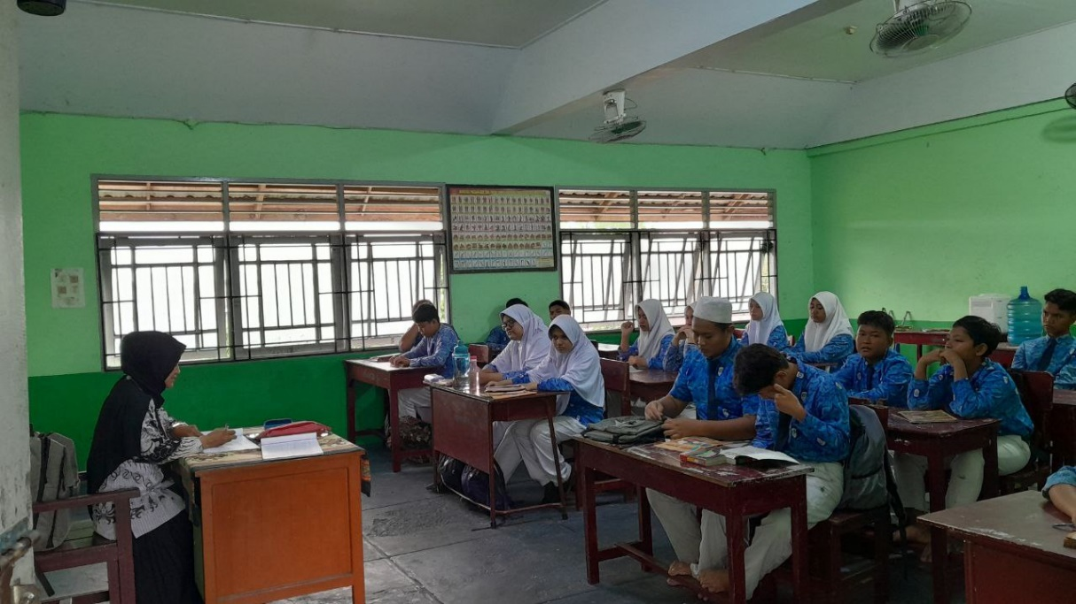
Documentation

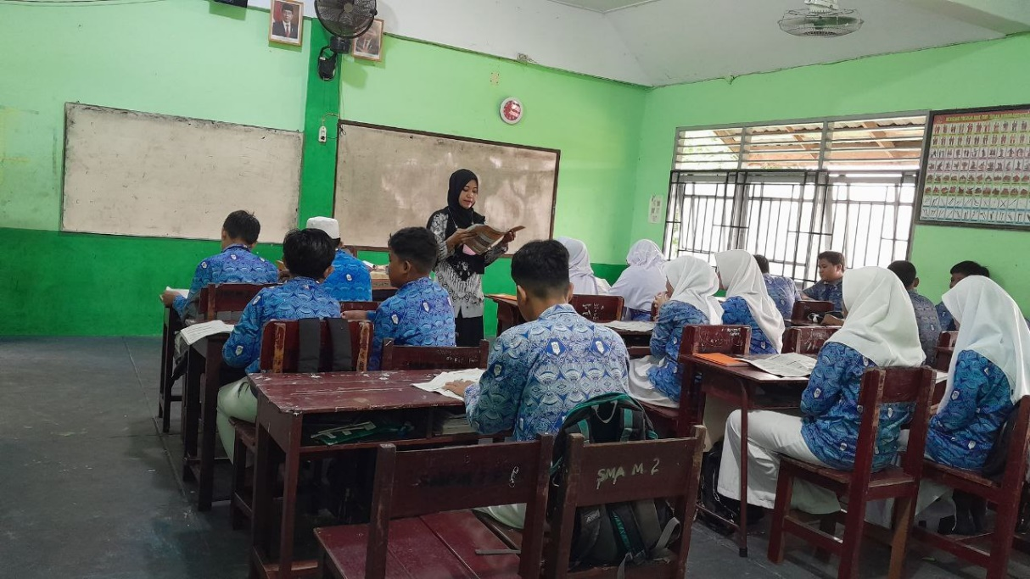
The teacher opens the class with greetings and asks students to pray then, the teacher checks the students' attendance.

The teacher reads the material which is then followed by the students
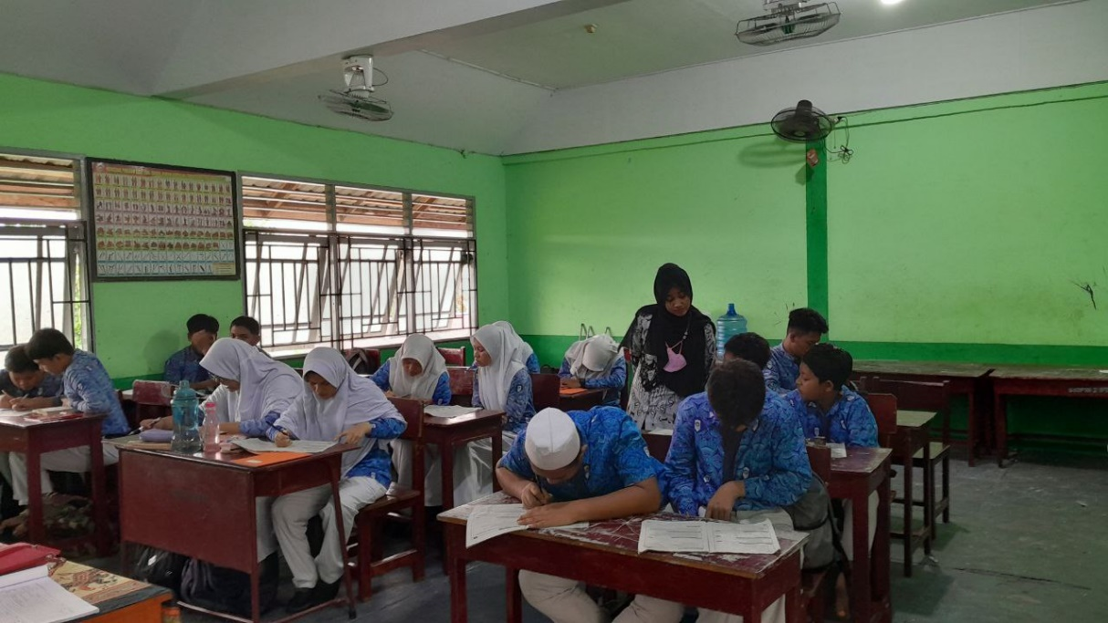

The teacher checked for students who did not do the assignment
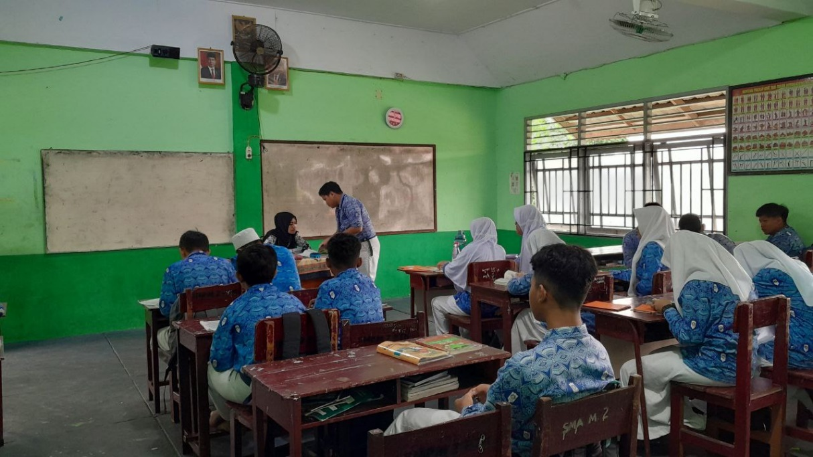

Students ask questions about material they do not understand

